Final Project Summary Document
Online Retail Customer Segmentation with K-Means, DBSCAN, Hierarchical Clustering and Business Rules
Scope: Covers all five Learning Day 8 notebooks and the official MVD checklist for clustering with K-Means, DBSCAN, Ward hierarchical clustering and Gap Statistic.

1. Project objective
The objective was to complete Learning Day 8 clustering end to end using a business-relevant Online Retail customer segmentation project. The work covers the official MVD requirements and extends them with professional clustering methods, outlier checks, density explanations and business-rule segments.
Notebook | Main work completed | Main output
Notebook 1 | Project setup, source audit, Online Retail cleaning, RFM creation and scaling | RFM customer table and scaled RFM features
Notebook 2 | Partitioning methods: K-Means, MiniBatchKMeans, K-Modes, medoid-style fallback and K-Prototypes | Main baseline: K-Means k=5
Notebook 3 | Density, grid, subspace and constraint-based methods | DBSCAN unusual-customer layer and business-rule segments
Notebook 4 | Ward hierarchical clustering, dendrogram and Gap Statistic | Practical hierarchical choice: k=3
Notebook 5 | MVD assignment proof checklist | 14/14 required MVD tasks covered

2. Data and feature engineering
Area | Implementation | Result
Raw dataset | Online Retail / online_retail_II.xlsx | 525,461 transaction rows and 8 raw columns
Cleaning focus | CustomerID, invoice status, quantity, unit price, duplicates | Removed non-customer and invalid transaction rows
Feature engineering | RFM per CustomerID | Recency, Frequency and Monetary customer-level features
Scaling | StandardScaler | Created scaled RFM for distance-based clustering
Visualisation | PCA | PC1 + PC2 explain 88.96% of scaled RFM structure

3. Methods implemented
Method | Notebook | Purpose
K-Means | Notebook 2 and 5 | Main partitioning baseline; tested k=3,5,7 and elbow k=1-10
MiniBatchKMeans | Notebook 2 | Fast partitioning comparison
K-Modes | Notebook 2 | Categorical customer behaviour clustering
Medoid-style fallback | Notebook 2 | Robust representative-point style comparison
K-Prototypes | Notebook 2 | Mixed numerical + categorical clustering
Outlier detection | Notebook 2 | Top 1%, IQR, Isolation Forest, LOF and strong outlier flags
DBSCAN | Notebook 3 and 5 | Density clusters and noise customers
OPTICS | Notebook 3 | Variable-density exploration
DENCLUE-style KDE | Notebook 3 | Density scoring layer
Grid/STING/Wave/CLIQUE | Notebook 3 | Density and subspace explanation
Constraint-based rules | Notebook 3 | Business-friendly VIP and reactivation segments
Ward hierarchical clustering | Notebook 4 and 5 | Dendrogram, Gap Statistic and final comparison

4. Main numerical results
k | Clusters | Inertia | Silhouette | Davies-Bouldin | Calinski-Harabasz
3 | 3 | 5160.2917 | 0.5891 | 0.5988 | 3246.4900
5 | 5 | 2740.1154 | 0.6140 | 0.6304 | 4006.5535
7 | 7 | 1820.1071 | 0.4948 | 0.6795 | 4381.9813

K-Means k=5 was selected as the main baseline because it had the strongest Silhouette score among the tested K-Means values and created a more usable business segmentation than k=3 or k=7.
Method | Clusters | Noise customers | Silhouette | Davies-Bouldin | Calinski-Harabasz | Best use
K-Means k=5 | 5 | 0 | 0.6140 | 0.6304 | 4006.5535 | Main segmentation baseline
DBSCAN | 3 | 63 | 0.6259 | 0.3119 | 68.1318 | Unusual customer detection layer
Hierarchical Ward k=3 | 3 | 0 | 0.5752 | 0.5914 | 3149.7195 | Supporting hierarchy view

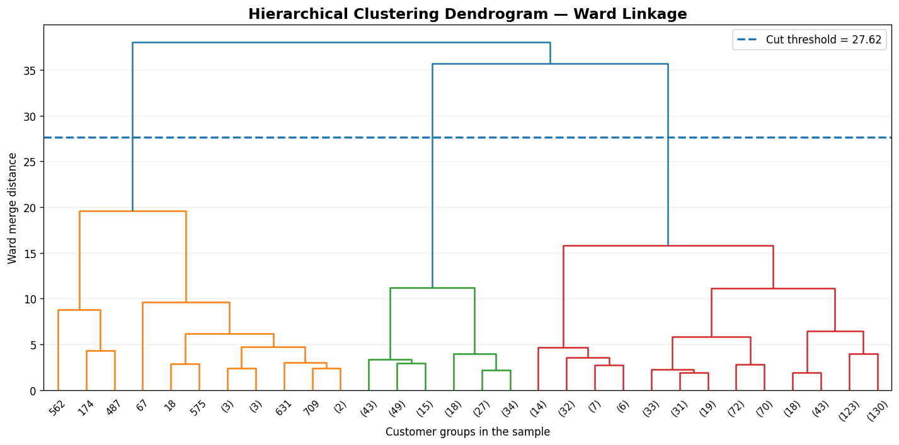
Ward linkage dendrogram supporting a practical hierarchical choice of k=3.
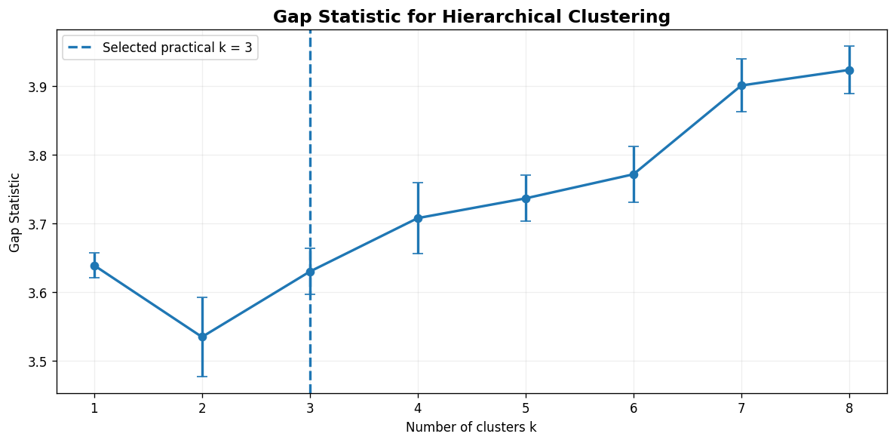
Gap Statistic curve for k=1 to 8; dendrogram and business readability support practical k=3.

5. MVD completion summary
Level | Requirement area | Status
Beginner | K-Means scatter, k=3/5/7, elbow k=1-10 | Covered
Intermediate | Online Retail RFM, StandardScaler, DBSCAN eps/min_samples grid, Silhouette comparison | Covered
Expert | Ward dendrogram, Gap Statistic B=10 for k=1-8, final metrics table | Covered
Overall | Official MVD checklist | 14/14 tasks covered

6. Final recommendation
Final recommendation: Use K-Means k=5 as the main segmentation baseline. Add DBSCAN as a second layer for unusual customers. Use hierarchical clustering, Gap Statistic and density/grid methods as supporting explanation and validation.

7. Submission file checklist
File | Role | Submission use
Notebook 1 | Data preparation and RFM setup | Keep as evidence for dataset and preprocessing
Notebook 2 | Partitioning methods | Keep as evidence for K-Means, elbow and partitioning comparison
Notebook 3 | Density and constraints | Keep as evidence for DBSCAN, OPTICS, grid, wave, CLIQUE and business rules
Notebook 4 | Hierarchical and Gap Statistic | Keep as evidence for expert task
Notebook 5 | MVD proof checklist | Use as the final assignment proof notebook

8. Interview-ready explanation
I built an end-to-end unsupervised learning project on Online Retail data. I converted transaction records into customer-level RFM features, compared partitioning, density-based and hierarchical clustering methods, and selected K-Means k=5 as the main segmentation baseline. I added DBSCAN for unusual customer detection and business-rule labels to make the result actionable for VIP handling and reactivation campaigns.

